SYSTEM DESIGN

Data Flow Diagram / Sequence Diagram / Component Diagram

The DFD is also called as bubble chart. It is a simple graphical formalism that can be used to represent a system in terms of the input data to the system, various processing carried out on these data, and the output data is generated by the system.
Data Flow Diagram
User
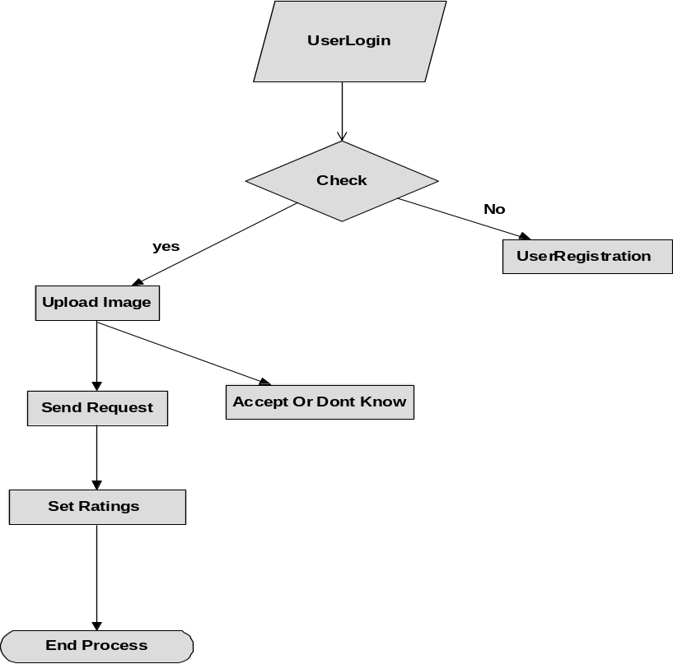

Sequence Diagram

User
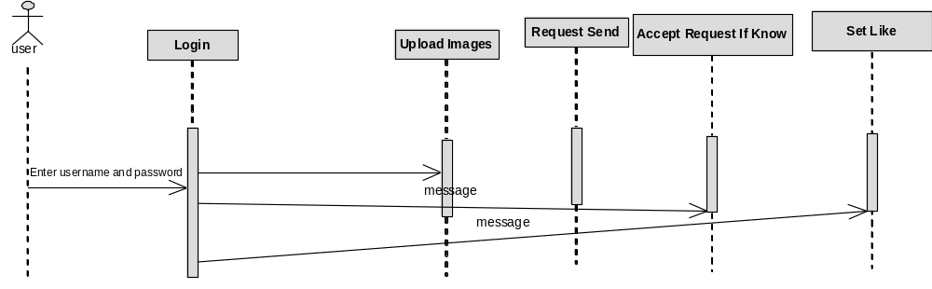

Component Diagram
User
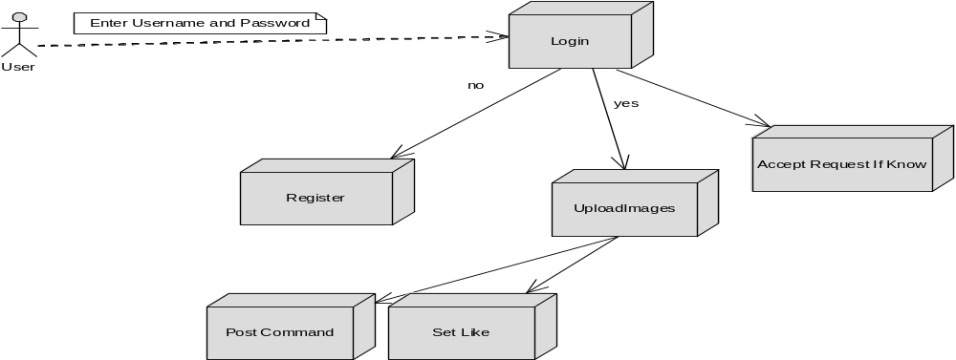

Activity Diagram:
UserLogin
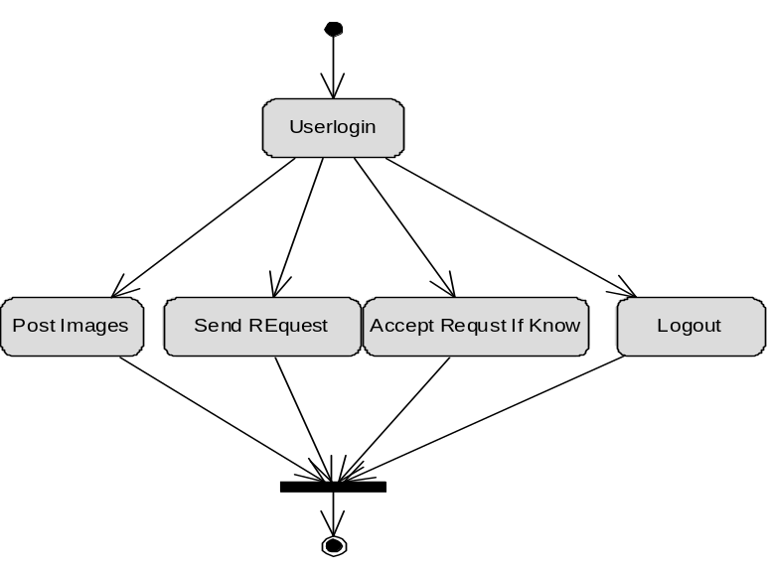

Class diagram
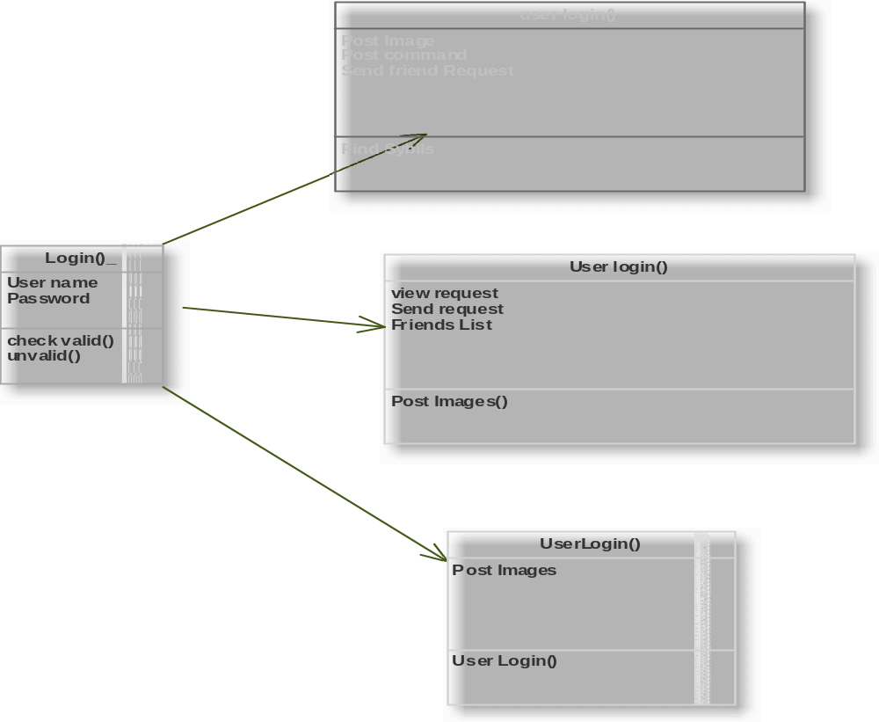

User Case Diagram
